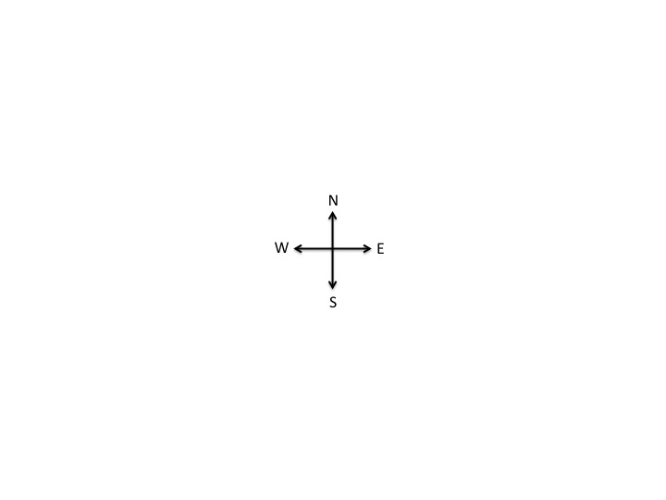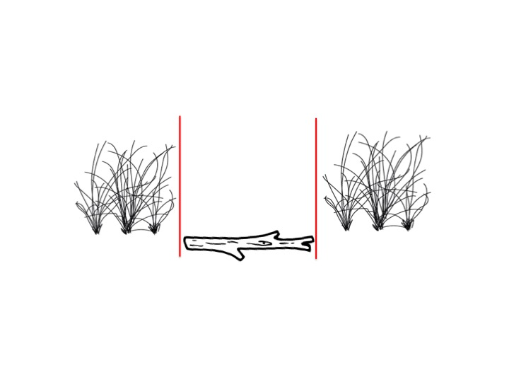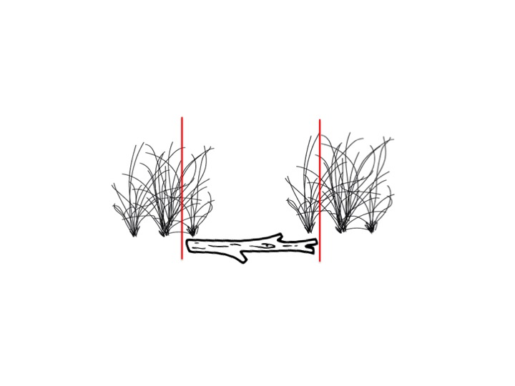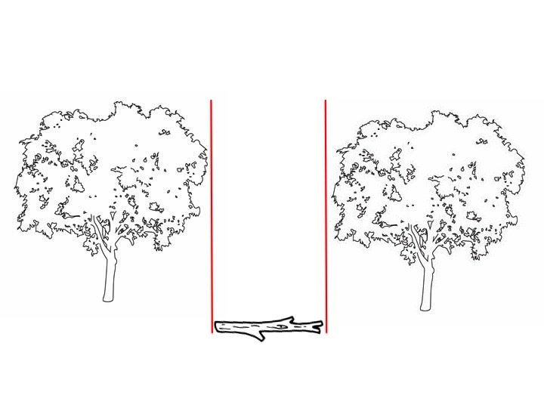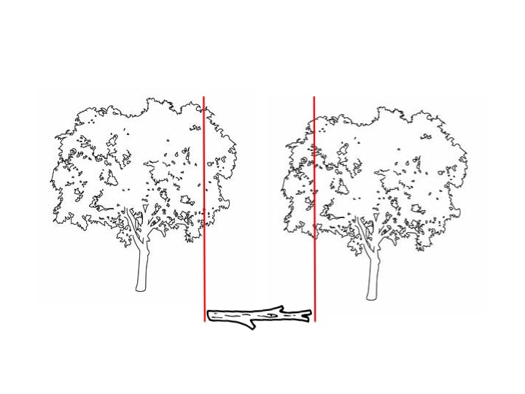

FADE TO: Two red lines will appear, perpendicular to stick. The stick is clearly touching the base of the plants. This image will show that there is a NOT a basal gap.

CUT TO: A person drops the stick between two plants. Two red lines will appear, perpendicular to stick. The stick is clearly not touching the base of the plants. This image will show that there is a basal gap.

OPEN TO: Cross at center of site. A person will begin walking in one of the directions with a stick in his hand.

CUT TO: A person will drop a stick in front of his feet. Two red lines will appear, perpendicular to the stick. The lines will clearly not be touching the canopy of the tree, showing that there is a canopy gap.

FADE TO: Two red lines will appear, perpendicular to the stick. The lines will clearly be touching the canopy of the tree, showing that there is NOT a canopy gap.